

Flight_Plan_Prediction

Submitted by:

Priyanka Soapraj

**ACKNOWLEDGMENT**

The project was done with the help of data-trained used cases which helped me to process and train by data set.

**INTRODUCTION**

* Business Problem Framing

Nowadays we can see an increase in the flight rates but not sure how the price may differ from one place to another place.

* Review of Literature

As per the research data set from the last 5 years the data have given a concept of how we can get the prediction price of each destination.

**Analytical Problem Framing**

* Mathematical/ Analytical Modeling of the Problem

Based on the date set we started with the selection of how many rows and columns, and which all data is required to build a model.

* Data Sources and their formats

The data set was in excel format and we imported pandas, NumPy, matplotlib & Seaborn.

* Data Preprocessing Done

What were the steps followed for the cleaning of the data? – For cleaning up the data we first started with removing the null value. What were the assumptions done and what were the next actions steps over that? – after the removal of the null value we started with the EDA process.

* Hardware and Software Requirements and Tools Used

The libraries used in this case are – Pandas, NumPy, Seaborn & Matplotlib.

**Model/s Development and Evaluation**

* Identification of possible problem-solving approaches (methods)

The data set was huge with the number of rows and columns we converted the data object into time stamp so it will be easy to work with test set and train.

* Testing of Identified Approaches (Algorithms)

ExtraTreesRegressor,

RandomForestRegressor &

RandomizedSearchCV.

* Run and Evaluate selected models

1) ExtraTreesRegressor

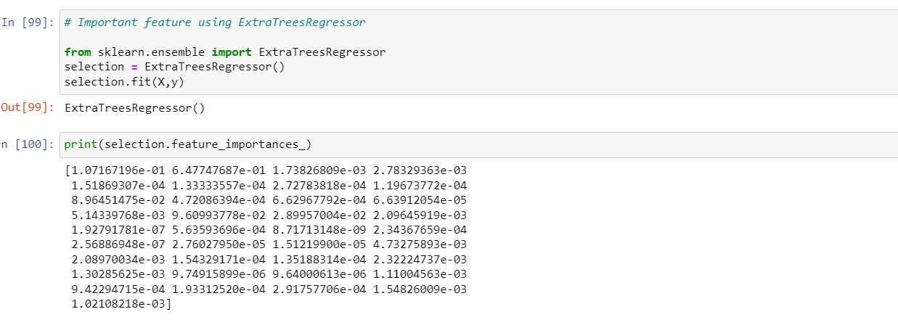

2) RandomForestRegressor

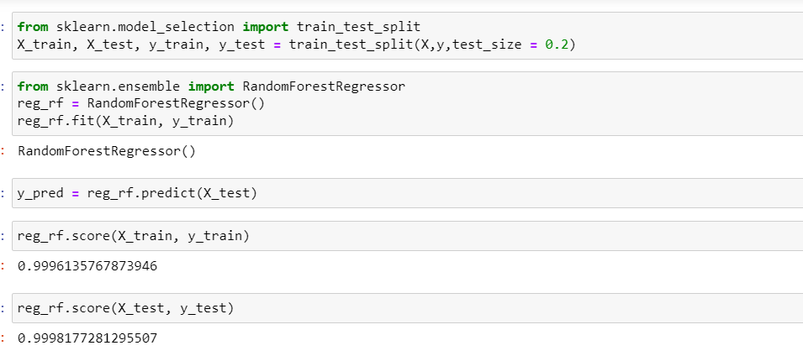

3) RandomizedSearchCV

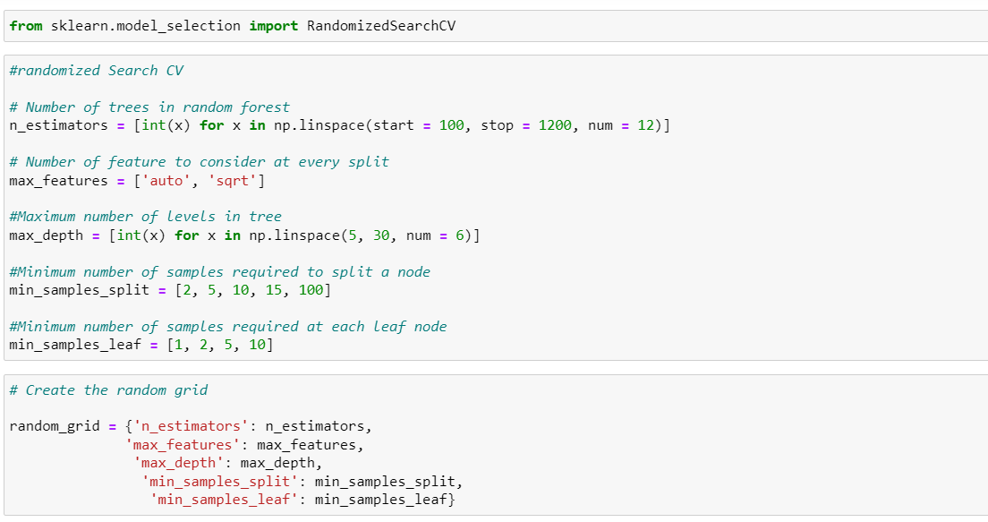

* Visualizations

Sns. heatmap – to find a correlation between independent and dependent attributes, plot graph – for feature importance for better visualization, Distplot & Scatter plot.

* Interpretation of the Results

After using the different algorithms and the plots we understand the data structure and got to know where we are still missing and done with tunning part to fit the model in test data.

**CONCLUSION**

* Key Findings and Conclusions of the Study

Overall though this data set and the model were taken to fit the model and get a good score in the final.